MAE94 Final Project:

Solar Powered Minicar

*Final Design Report*

Prof. R.S. Shaefer

TA: Amirhossein Ahmadian

By

Chenyang Wang

105425757

MAE94 – Introduction to Computer Aided-Design and Drafting

Mechanical and Aerospace Engineering Department

University of California Los Angeles

08/10/2020

**Abstract**

How to use new energy is one of the most important topics in this era, and renewable energy such as solar power becomes more and more important in many aspects of our daily lives. This report documents the design of a solar powered minicar for the MAE-94 Final Project. In this report, every phase of the development will be discussed, from developing the concepts to performing Finite Element Analysis (FEA) on the completed minicar chassis. The description of the parts used for the minicar will also be provided, together with an appendix containing the detailed parts and assembly engineering drawings.

**Table of Contents**

1. Introduction 6

1.1 Problem Statement 6

1.2 Design Requirements 6

2. Design Description 6

2.1 Design Concept Development 6

2.2 Design Overview 8

2.3 System Specifications 9

2.4 Mechanical Systems 10

3. FEA Analysis 15

3.1 Description of FEA Analysis 15

3.2 Boundary Conditions 16

3.3 Analysis Results 16

4. Product Fabrication 18

5. Summary and Conclusions 18

6. References 19

7. Appendix 20

**List of Figures**

Figure 1. Mini-car concept 1 7

Figure 2. Mini-car concept 2 7

Figure 3. Mini-car concept 3 8

Figure 4. An isometric view of the entire model 9

Figure 5. An isometric view of the motor 10

Figure 6. An isometric view of the pinion 10

Figure 7. An isometric view of the gear 11

Figure 8. An isometric view of the solar panel 11

Figure 9. An isometric view of the ball of the joystick 12

Figure 10. An isometric view of the socket of the joystick 12

Figure 11. An isometric view of the solar panel subassembly 12

Figure 12. An isometric view of the axle 13

Figure 13. An isometric view of the screw 13

Figure 14. An isometric view of the chassis 14

Figure 15. An isometric view of the wheel 14

Figure 16. An isometric view of the washer 14

Figure 17. The simplified chassis 15

Figure 18. Boundary Conditions applied on the chassis 16

Figure 19. Chassis stress contours resulting from an applied load of 500 N 16

Figure 20. Chassis stress contours resulting from an applied load of 2000 N 17

Figure 21. Chassis stress contours resulting from an applied load of 4500 N 17

Figure 22. Chassis stress contours resulting from an applied load of 4000 N 18

**List of Tables**

Table 1. Device Specifications and Dimensions 10

1. **Introduction**
   1. *Problem Statement*

The class of Summer 2020 MAE 94 (Introduction to Computer-Aided Design and Drafting) was tasked with creating a minicar that used a solar panel, a motor, bevel gears, an axle, screws, together with a panel mount to travel on a flat surface based on specified Design Requirements, which will be introduced in the following section. The development started with coming out three design concepts, and the best one was chosen according to some criteria which will also be discussed in the following sections. The design was then modeled by using Solidworks and performed a Finite Element Analysis (FEA).

* 1. *Design Requirements*

The Design Requirements (DRs) of this project consists of the following:

(1) The device must reach maximum speed within 30 feet of travel on a flat surface.

(2) Device dimensions are not to exceed 0.20 x 0.20 x 0.30 m3

(3) The device must utilize a 2’’x 2’’ solar panel and the DC motor – no other power source or means of transportation can be used.

(4) Use of the bevel gears is optional – own gears can be designed

(5) Metal fasteners, such as rods or pins made of metal are allowed, but are limited to a diameter of 1-mm.

(6) Power transmission components (motor, gears, axles, …) should be mounted/attached using supplied screws (use as many M2x6 screws as needed).

(7) All structural components must be either laser-cut from a single 24’’x 24’’ Acrylic Sheet – 1/8’’ thick (3.175mm) or 3D-printed (ABS).

(8) Structural components may be assembled with or without adhesive (Gorilla Glue).

Every attempt was made during the development of the minicar to adhere to these design requirements, and indeed the final product fulfills all these requirements.

1. **Design Description**
   1. *Design Concept Development*

We were tasked to develop three different (not variations), but fundamentally different mini-car concepts based on given design requirements. The sketches for these three concepts together with some description of the fundamental features of the concepts are presented in the following pages.

**Concept-1**: Below is the hand-sketch of the first concept. This is a rather simple concept. As can be seen in the sketch, it is a three-wheel car and it is rear-wheel drive. The motor and the gears are placed in the rear and the solar panel and the panel mount is place in the front to balance the weight. Besides the essential parts, other materials are used as fewer as possible to lower the entire weight of the car to reach the speed as sooner as possible.

Figure 1. Mini-car concept 1

**Concept-2:** Below is the hand-sketch of the second concept. In this concept, we can see that it is a four-wheel car with rear-wheel drive. There is a base (chassis) and the motor together with the solar panel are placed on the base with no panel mount used. The use of chassis and fewer links as possible is to make the entire structure stable.

Figure 2. Mini-car concept 2

**Concept-3:** Below is the hand-sketch of the third concept. We can see that it is a two-wheel car. Two support links are used, one for the motor and one for the solar panel. This design must be the lowest weight, however the issue needs to solved is the length of each link so that the entire car can be balanced, which can be really hard.

Figure 3. Mini-car concept 3

The primary candidate turned out to be the second concept. Compare to the first and third concept, although it uses more materials, it is easier to achieve stability (balance) and it is easier to assemble. Although the first concept could also be a potential candidate, to find the balance may need some extra works. For the third concept, it is the simplest concept, however, as mentioned above, finding the balance can be really hard. Thus, to ensure we will have a deliverable that meets the Design Requirements, the final design is developed based on the second concept with few necessary modifications.

* 1. *Design Overview*

In this section, a brief description as well as an isometric view of the entire car will be given. To build the model, we are given already built parts including the motor, gears, axle, solar panel, solar panel mount and screws. And the only parts that were designed during the process are the chassis, the wheels, and the washer for the axle. Detailed descriptions of these parts will be given in the following sections.

The design was developed following closely to the selected design concept with a few modifications. First of all, in the design concept, there is only the solar panel on the chassis, however in order to maximize the sun exposure, addition solar panel mount was added in the development of the model. With the solar panel mount, the solar panel can be tilted and rotated to maximize the sun exposure. In addition, according to the design concept, the solar panel was placed in the middle of the chassis, however, considering the total balance of the car, it was moved to the right a little in order to balance with the motor. The solar panel will provide energy for the motor, and the motor placed in the rear will drive the rear wheels together with two gears. An isometric view of the entire car is given below:

Figure 4. An isometric view of the entire model

* 1. *System Specifications*

In this section, a summary table listing dimensions and system parameters will be provided, and the table is shown below:

|  |  |
| --- | --- |
| **Parameter** | **Value** |
| Total Length | 198 mm |
| Total Height | 75 mm |
| Total Width | 150 mm |
| Chassis and Wheel Material | ABS |
| Chassis Weight | 106.87 g |
| Chassis Length | 140 mm |
| Chassis Height | 10 mm |
| Chassis Width | 100 mm |
| Wheel Weight | 41.83 g |
| Wheel Diameter | 75 mm |
| Wheel Thickness | 10 mm |

Table 1. Device Specifications and Dimensions

* 1. *Mechanical Systems*

In this section, a brief description and an isometric view will be given for the already-built parts, and a detailed description and an isometric view will be given for the designed parts. The given parts are the motor, gears, axle, solar panel, solar panel mount and screws. Below are the isometric views for these parts.

Figure 5. An isometric view of the motor

The motor is connected with the solar panel to gain the energy, and uses the energy to drive the rear wheels of the car.

Figure 6. An isometric view of the pinion

The original given pinion was a bevel gear, and according to Professor Shaefer’s comment, it was replaced by a spur gear. The pinion is connected directly with the motor, and it services as the driving gear.

Figure 7. An isometric view of the gear

The original given gear was a bevel gear, and according to Professor Shaefer’s comment, it was replaced by a spur gear. In addition, since the axle is hexagonal, and in order for the axle to engage mechanically with this gear, the hole of this gear is modified to also be hexagonal with the same size of the axle.

Figure 8. An isometric view of the solar panel

Figure 9. An isometric view of the ball of the joystick

Figure 10. An isometric view of the socket of the joystick

The solar panel is used to provide energy for the motor. In addition, in order to maximize sun exposure, the solar panel should be able to be rotated and tilted. The original given solar panel mount, or the joystick, can only rotate the panel, thus few modifications are made to the ball and the socket of the joystick to make sure that the panel can be also titled. An isometric view of the solar power system is shown below.

Figure 11. An isometric view of the solar panel subassembly

Figure 12. An isometric view of the axle

There are two axles, one in the front and one in the rear. There are used to connect the two front wheels and two rear wheels.

Figure 13. An isometric view of the screw

In this design, two screws are used to mount the motor onto the chassis.

Figure 14 below shows the designed chassis for the minicar. The circular hole on top of the chassis is used to mount the solar panel subassembly. The motor mount in the rear of the chassis is used to fix the motor, and two small holes on the mount are used to mount the screws. Fillets are applied on the edge of the chassis, and two extruded cuts are applied in order to reduce weight. As mentioned earlier, the solar panel is placed to the right of the chassis in order to balance the weight of the motor in the left of the chassis.

Figure 15 below shows the designed wheel. Since the axle connecting the left and right wheels is hexagonal, and in order for the axle to engage mechanically with the wheels, the hole of the wheel is modified to also be hexagonal with the same size of the axle. Six circular patterned circular extruded cuts are applied in order to reduce weight. And fillets are applied on the edge of the wheel.

Figure 16 below shows the designed washer. Because the chassis’ axial holes are designed to be circular while the axles are hexagonal, this tight-fitting washer are designed to ensure that the axles can rotate freely in the chassis holes while preventing the axles from sliding. Detailed engineering drawings of these parts are provided in Appendix B.

Figure 14. An isometric view of the chassis

Figure 15. An isometric view of the wheel

Figure 16. An isometric view of the washer

1. **FEA Analysis**
   1. *Description of FEA Analysis* [1]

In general, the Finite Element Analysis (FEA) is a computerized method for predicting how a component or assembly will react to some external ‘loads’, such as forces, acceleration, heat, etc. There are several advantages of doing FEA. The first one is that cost can be reduced by only simulating the performance of the model instead of building it and testing it. In addition, FEA can reduce time to market by reducing the number of product development cycles. What’s more, FEA can also improve products by just quickly testing some concepts and scenarios before making the final decision, thus giving more time to think of new designs.

FEA is based on the Finite Element Method (FEM). In general, the FEM is a numerical method for solving Boundary Value Problems (BVPs). And in particular, a BVP is a mathematical problem made of two parts, a partial differential equation (PDE) and some boundary conditions (BCs). In our case, we can think of the BCs as restraints and external loads of the model. Details on setting up the BCs will be discussed in the next section. The basic idea of FEA is to break the model into many small ‘elements’ that are joined at some ‘nodes’, then the problem can be simplified to just finding the solutions only at these ‘nodes’, thus it is a ‘discrete’ problem can be solved numerically.

In the following sections, a FEA of the chassis of the minicar will be performed to determine the maximum load that the chassis can handle without yielding. And note that in order to perform FEA correctly in Solidworks, the chassis is assumed to be made of Acrylic (medium high impact).

Before applying the BCs, we need to simplify the model. To simplify the model, we need to suppress features or parts that are not contributing to the strength of the chassis, and as can be seen in Figure 14, the motor holder and fillets can be removed, as these features are not critical to the strength of the chassis. Thus, the simplified model of the chassis is shown below:

Figure 17. The simplified chassis (motor holder and fillets removed)

* 1. *Boundary Conditions*

Next, the boundary conditions need to be added. There are two BCs, the fixtures and the loads. Since the axles are pushing up against the top face of the axle holes, the axle holes need to be split using **split lines** and only fix the top halves inside the axle holes. For the load, the assumption here is that someone will step on the entire chassis, thus giving an external load to the chassis. A figure of the chassis showing applied loads and fixture is shown below:

Figure 18. Boundary Conditions applied on the chassis

* 1. *Analysis Results*

A load of 500 N was used to initiate the analysis, and the load will be gradually increased to determine the maximum stress that the chassis can withstand without yielding. The result of the first run is shown below:

Figure 19. Chassis stress contours resulting from an applied load of 500 N (maximum stress is 5.58 MPa;

yield strength is 45 MPa)

Next, for the second run, the load is increased from 500 N to 2000 N, and the result is shown below:

Figure 20. Chassis stress contours resulting from an applied load of 2000 N (maximum stress is 22.3 MPa)

For the third run, the load is increased from 2000 N to 4500 N, and the result is shown below:

Figure 21. Chassis stress contours resulting from an applied load of 4500 N (maximum stress is 50.2 MPa)

As can be seen in the above figure, the maximum stress is larger than the yield strength, thus yielding will happen. Thus, for the next run, the applied load is decreased to 4000 N. And the result is shown below in Figure 22. As can be seen in this result, the maximum stress is 44.6 MPa while the yield strength is 45 MPa, thus it is safe to say that the maximum stress that the chassis can withstand without yielding is 4000 N, thus concludes the FEA analysis.

Figure 22. Chassis stress contours resulting from an applied load of 4000 N (maximum stress is 44.6 MPa)

1. **Product Fabrication**

According to one of the Design Requirements, which states that ‘All structural components must be either laser-cut from a single 24’’x 24’’ Acrylic Sheet – 1/8’’ thick (3.175mm) or 3D-printed (ABS)’, this minicar can either be produced by an Acrylic Sheet if choose to use laser-cut or 3D-printed. The original plan for this minicar was to use the 3D printer from UCLA, however due to the COVID-19 pandemic, the campus is closed. Thus, neither the 3D-printing nor the laser-cutting service is available. In this case, the product fabrication needs to be postponed until the campus is re-open.

1. **Summary and Conclusions**

In this report, each part of the development process is discussed, from developing the initial concepts to performing FEA analysis of the final product. In summary, three different design concepts were developed and considered at the beginning of the development process, and the best one was chosen after considering the strengths and weaknesses of each concept. Following closely to the chosen design concept and the design requirements, parts were created, and assembly was made by using Solidworks. All the design requirements except the first one stating that ‘The device must reach maximum speed within 30 feet of travel on a flat surface’ were satisfied by precise measurements. After the solid model was created, a FEA analysis was performed on the chassis of the minicar, and the result turned out to be that 4000 N of stress is the maximum stress that the chassis can withstand without yielding.

For future work, because of the COVID-19 pandemic, this minicar cannot be 3D printed, assembled, and tested in real environment due to campus shut-down. Thus, whether the final product will meet the first design requirement remains unknown. Thus, in the coming months, once the campus reopens, this minicar will then be produced by using UCLA’s 3D printer and be assembled as soon as possible to test the performance in real environment.

1. **Reference**

[1] Robert S. Shaefer, ‘Finite Element Analysis (FEA) Using SOLIDWORKS’, Lecture-6B, Summer 2020

1. **Appendix**
2. *Isometric View of a Shaded Image of the Assembled Device*

1. *Working Drawing Package*
2. Assembly Drawing with BOM

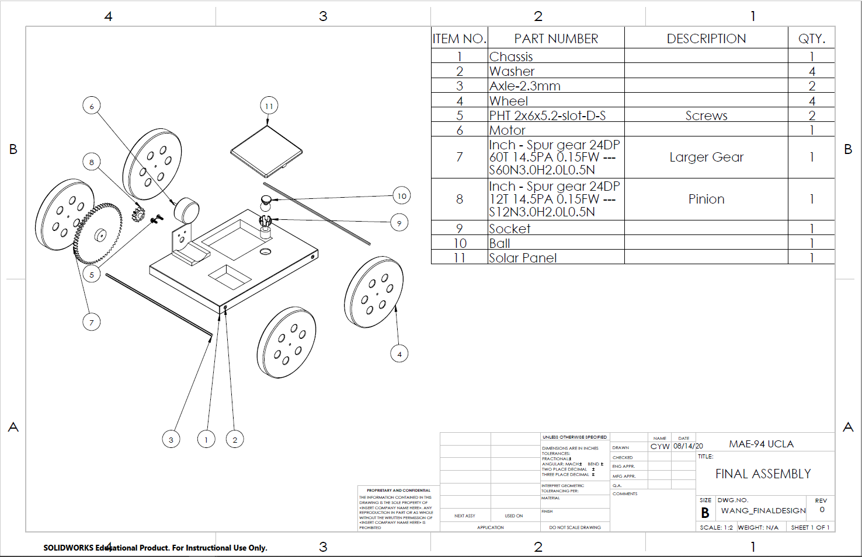

1. Detail Part Drawing

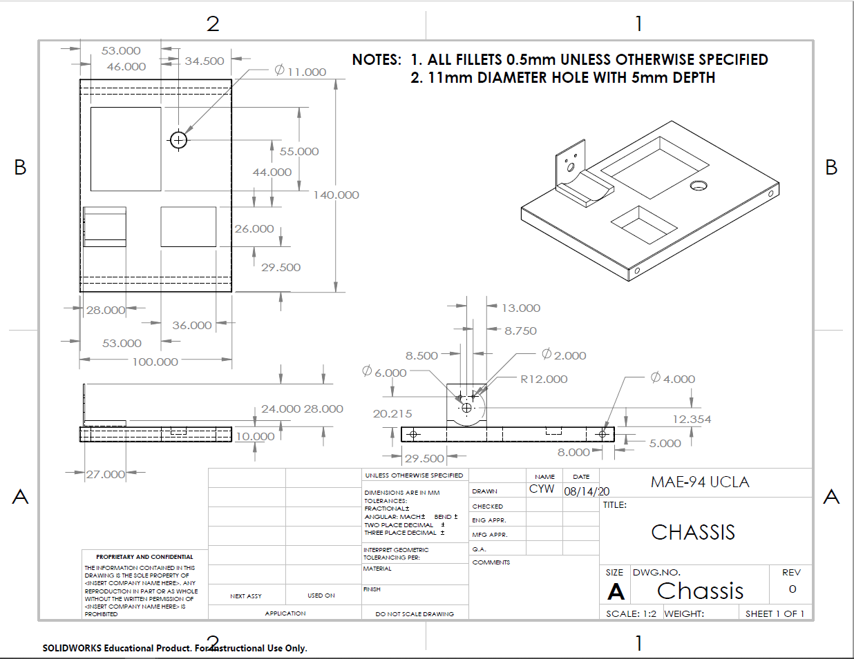

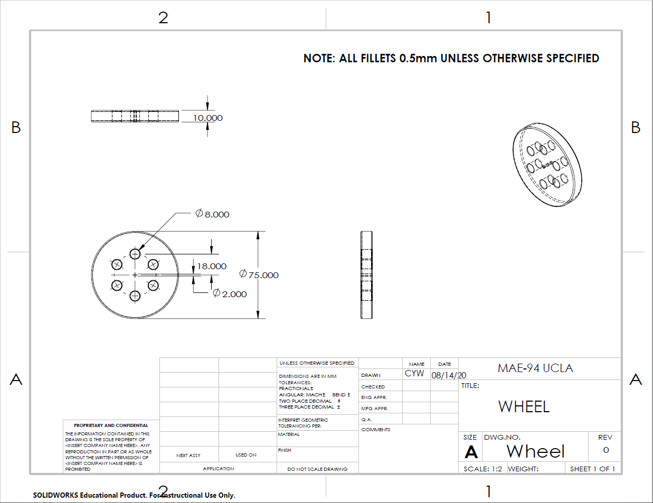

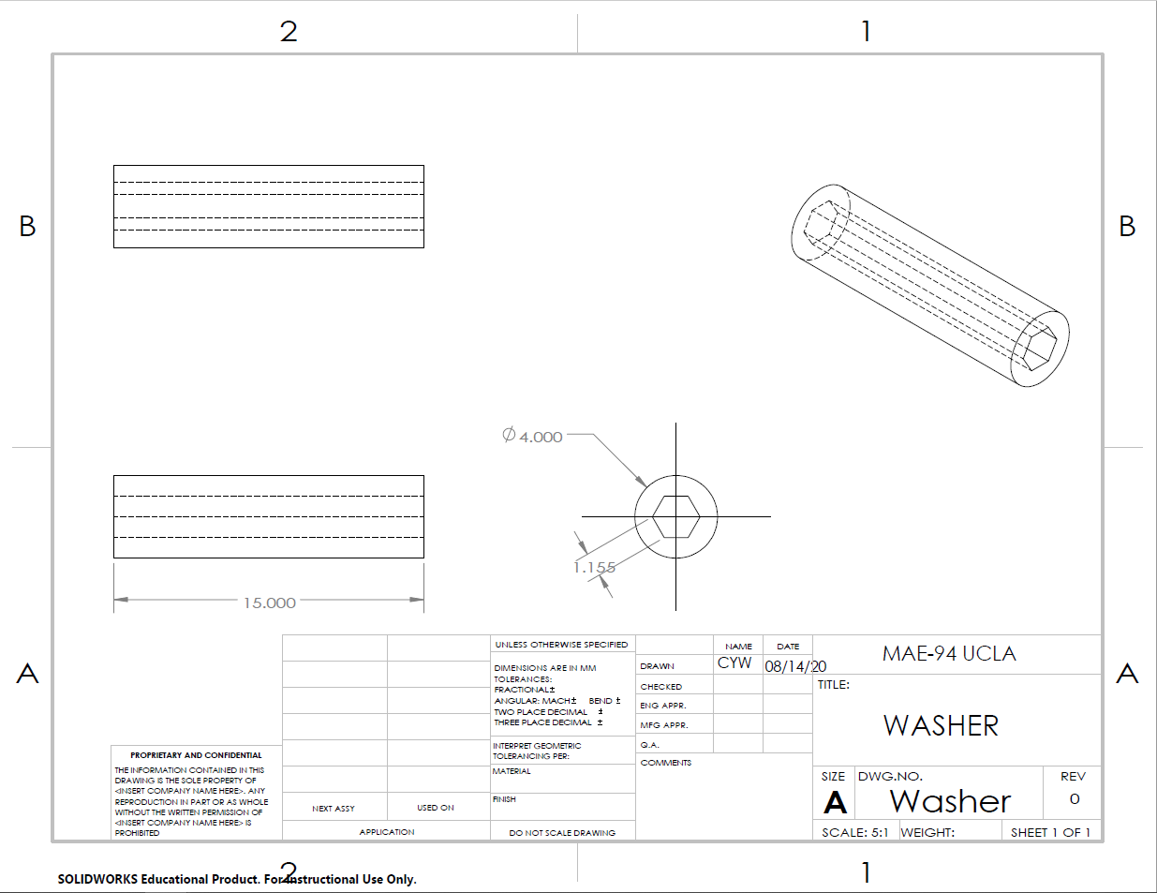

1. Standard Parts Sheet

